**Title:** **Eco Transit Solution**

**A SOCIALLY RELEVANT PROJECT REPORT**

Submitted in partial fulfillment of the requirements for the award of the degree of

Bachelor of Technology

In

COMPUTER SCIENCE AND INFORMATION TECHNOLOGY

By

Reg No:

V.Roshitha -22331A0755



**DEPARTMENT OF INFORMATION TECHNOLOGY MVGR COLLEGE OF ENGINEERING (Autonomous) VIZIANAGARAM-535005, AP (INDIA)**

**DECLARATION**

I hereby declare that the project entitled **"Eco Transit Solution**" submitted for the fulfilment of Mini Project in B.Tech Degree is my original work and the project has not formed on the basis for the submission in any degree or any other similar titles.

V.Roshitha -22331A0755

**PLACE:**

**DATE:**

**CERTIFICATE**



This is to certify that the project report entitled “Eco Transit Solution"is being submitted by V.Roshitha ,bearing registered numbers 22331A0755 , respectively, in partial fulfilment for the award of the degree of “Bachelor of Technology” in COMPUTER SCIENCE AND INFORMATION TECHNOLOGY is a record of bonafide work done by them under my supervision during the academic year 2024-2025.

Dr.v.Nagesh Dr. P.SRINIVAS RAO

Project Coordinator, Head of the Department,

Department of IT Department of IT,

MVGR College of Engineering. MVGR College of Engineering.

**TABLE OF CONTENT**

|  |  |  |
| --- | --- | --- |
| **CHAPTER** | **TITTLE** | **PAGE NO.** |
| **1** | **Abstraction** | **5** |
| **2** | **Introduction** | **6** |
| **3** | **Problem statement** | **7** |
| **4** | **System requirement** | **8** |
| **5** | **Technologies used** | **9** |
| **6** | **Existing system** | **10** |
| **7** | **Proposed system** | **11** |
| **8** | **Use-case** | **12** |
| **9** | **Process-flow** | **13** |
| **10** | **Sample code** | **14 -16** |
| **11** | **Output screenshots** | **17-19** |
| **12** | **Advantages** | **20** |
| **13** | **Limitations** | **21** |
| **14** | **conclusion** | **22** |
| **15** | **FutureScope** | **23** |
| **16** | **reference** | **24** |

**ABSTRACT:**

As urbanization and environmental concerns escalate, there is a critical need for accessible, consolidated information on sustainable transportation options. The proposed website aims to address this gap by serving as a comprehensive, user-friendly platform dedicated to promoting sustainable transportation practices. The site will provide a centralized hub for information on various eco-friendly transportation modes, including electric and hybrid vehicles, public transit, cycling, and walking. It will feature interactive tools for route planning, vehicle comparisons, and energy efficiency calculations, along with educational resources and updates on relevant policies and incentives. Additionally, the website will foster community engagement through forums and feedback mechanisms, encouraging users to share insights and experiences. By offering these resources, the website seeks to empower individuals, businesses, and policymakers to make informed decisions, thereby advancing the adoption of sustainable transportation solutions and contributing to environmental and urban mobility goals.

**Introduction:**

Eco Transit Solutions is a forward-thinking initiative dedicated to transforming the way we approach transportation. In an era where urbanization and pollution are growing at an unprecedented pace, the need for sustainable transit options has never been more crucial. Eco Transit Solutions aims to address these challenges by offering innovative, environmentally friendly transportation alternatives that not only reduce carbon footprints but also contribute to the overall improvement of urban mobility. By promoting the use of electric vehicles, bicycles, public transportation, and cutting-edge transit technologies, we strive to ease traffic congestion, enhance air quality, and create a greener, more efficient transportation network. Our vision is to foster a future where transportation is not only accessible and convenient but also kind to our planet, helping to safeguard the environment for generations to come. With a focus on sustainability, innovation, and efficiency, Eco Transit Solutions is committed to shaping the future of mobility and ensuring a cleaner, healthier world for all.

**Problem statement:**

The rapid growth of urban areas and increasing environmental concerns highlight the urgent need for accessible and actionable information on sustainable transportation options. However, current resources often lack centralized, user-friendly platforms that provide comprehensive and up-to-date information on sustainable transportation choices, technologies, and policies. The challenge is to develop a website that serves as a comprehensive, engaging, and accessible resource for individuals, businesses, and policymakers. This site should offer detailed information on sustainable transportation options, including electric and hybrid vehicles, public transit, cycling, and walking. It should also feature tools for planning, comparison, and decision-making, along with updates on relevant policies and incentives.

**System Requirements:**

**Hardware Requirements:**

Server: Linux-based or Windows-based server with at least 4GB RAM and 50GB storage.

Client Devices: Any device capable of browsing the internet, such as a desktop, laptop, tablet, or smartphone.

Internet Connection: High-speed broadband connection to ensure smooth browsing experience.

**Storage:** Adequate storage space for multimedia files (videos, images).

**Software Requirements:**

Operating System (Server): Linux/Windows (Apache/Nginx).

Database: MySQL or MongoDB for data storage.

Web Technologies: HTML5, CSS3, JavaScript

Image Handling: JPEG and PNG for images.

Text Editor/IDE: Visual Studio Code

Version Control: Git for source control and collaboration.

Browser Support: Chrome, Firefox, Safari, and Edge for seamless browsing experience.

**Technologies Used:**

**HTML5:**  
HTML5 is the core markup language used for structuring the content on web pages. It introduces new semantic elements and multimedia support, enabling websites like Eco Transit Solutions to have a well-organized, accessible layout with enhanced browser compatibility. HTML5 forms the backbone of modern web development.

**CSS3:**  
CSS3 is used for styling the website, providing visual design and layout control. It allows for responsive design, animations, and advanced visual effects that enhance the user experience. In Eco Transit Solutions, CSS3 ensures the site is visually appealing, easy to navigate, and optimized for all devices.

**JavaScript:**  
JavaScript adds interactive functionality to the Eco Transit Solutions website, allowing users to interact with elements dynamically. Whether it's animations, form validations, or responsive menus, JavaScript helps create a seamless and engaging experience for visitors.

**Existing System:**.

The existing transportation system in many urban areas is characterized by a heavy reliance on traditional internal combustion engine vehicles, which significantly contribute to high levels of carbon dioxide emissions and other harmful pollutants. These vehicles not only exacerbate air quality issues but also lead to increased traffic congestion, noise pollution, and a range of health problems for urban residents. Public transport options, such as buses and trains, do exist in many cities; however, they are often under-utilized due to several factors, including a lack of public awareness, infrequent scheduling, and poor last-mile connectivity that makes it difficult for users to reach their destinations efficiently. Furthermore, many existing platforms do not adequately promote eco-friendly transit alternatives or provide the necessary information for users to make informed choices about sustainable transportation. Consequently, the potential benefits of greener transit options remain untapped, leaving many urban areas struggling to balance the demands of transportation with the need for environmental sustainability

**Proposed System:**

The proposed system aims to transform the way urban residents approach transportation by developing a comprehensive web platform dedicated to promoting eco-friendly alternatives. This platform will serve as a central hub for information regarding the various benefits of electric vehicles, detailed cycling routes, public transit schedules, and localized pollution statistics. By providing users with easy access to this valuable data, the platform will empower them to compare the environmental impacts of different transit options, ultimately facilitating more informed decision-making. Additionally, the proposed system will include educational content aimed at raising awareness about the importance of sustainable transit practices, encouraging users to adopt greener habits in their daily commutes. By fostering a community of informed citizens who prioritize eco-friendly transportation, the system aims to mitigate the negative impacts of conventional vehicles and contribute to a cleaner, healthier urban environment. Through these initiatives, the proposed platform seeks to drive a cultural shift toward sustainability in transportation, ensuring that residents are well-equipped to make choices that benefit both themselves and the planet.

**Use-case:**

User Accesses the Website: The primary actor (user) visits the Eco Transit Solutions platform through a web browser. They are motivated by the desire to explore greener transportation options or learn more about reducing their carbon footprint.

Explores Transportation Alternatives: The user navigates the website to find various transportation alternatives, including electric vehicles, cycling routes, public transportation schedules, and pollution rate statistics. They might be interested in comparing the environmental impact of different transit options.

Views Educational and Informative Content: The platform provides educational materials, such as articles, videos, and infographics that explain the benefits of eco-friendly transportation. The user can access multimedia content that informs them about the advantages of using sustainable modes of transport.

Receives Pollution Data: The system offers real-time or updated pollution statistics in various urban areas, helping users understand the current environmental conditions. Based on this data, users can make better-informed decisions about their transit options.

Adopts Eco-Friendly Transit Practices: After reviewing the information provided by the system, the user is encouraged to adopt more eco-friendly practices, such as using electric vehicles, cycling, or taking public transportation, which align with their goals of reducing environmental impact.

Further Interaction: The user can return to the platform regularly to stay updated on pollution rates, new eco-friendly practices, and updated transportation routes.

**Process Flow:**

User Access: Users access the website to learn about various eco-friendly transit options.

Content Display: The platform provides details on goals, services, precautions, and pollution statistics.

Multimedia Integration: Videos and images demonstrate the impact and benefits of using green transportation.

Actionable Insights: Users are guided on how they can contribute to reducing pollution by adopting alternative transit options.

Data Monitoring: The platform tracks pollution rates and provides periodic updates to keep users informed of progress.

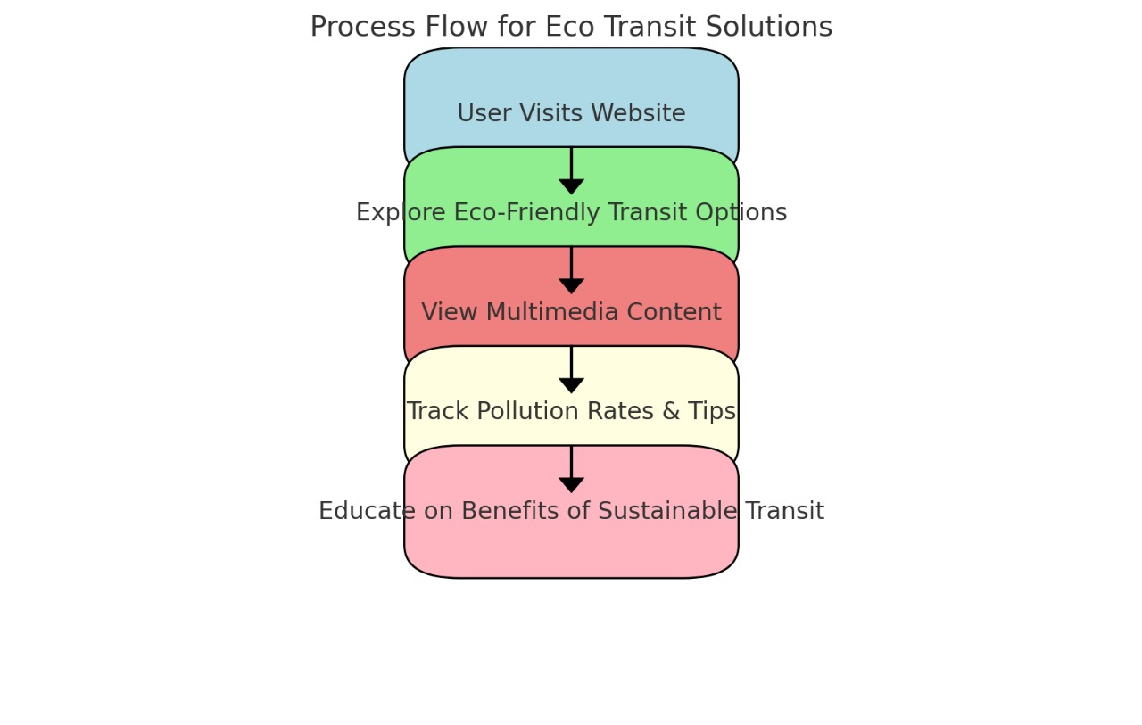

**Sample code:**

<!DOCTYPE html>

<html lang="en">

<head>

<meta charset="UTF-8">

<meta name="viewport" content="width=device-width, initial-scale=1.0">

<title>Eco Transit Solution</title>

<link rel="stylesheet" href="style.css">

</head>

<body>

<!-- Header Section -->

<header>

<div class="container">

<div class="logo">

<h1>Eco Transit Solutions</h1>

</div>

<nav>

<ul>

<li><a href="about.html">About</a></li>

<li><a href="goals.html">Goals</a></li>

<li><a href="precautions.html">Precautions</a></li>

<li><a href="services.html">Services</a></li>

<li><a href="pollution.html">Pollution Rate</a></li>

<li><a href="login.html">Login</a></li> <!-- New Login Tab -->

</ul>

</nav>

</div>

</header>

<!-- Main Content -->

<section class="hero">

<div class="container">

<h2>Eco Transit Solutions for a Greener Future</h2>

<p>We offer innovative transportation solutions to reduce environmental impact.</p>

<!-- Learn More Button with Link to Goals Page -->

<a href="goals.html">

<button class="learn-more-btn">Learn More</button>

</a>

</div>

</section>

<!-- Services Section -->

<section class="services">

<div class="container">

<div class="service-box">

<h3>About Eco Transit</h3>

<p>Our mission is to create eco-friendly transportation solutions.</p>

<a href="about.html" class="read-more-btn">Read More</a>

</div>

<div class="service-box">

<h3>Our Goals</h3>

<p>We aim to reduce carbon footprints through innovative services.</p>

<a href="goals.html" class="read-more-btn">Read More</a>

</div>

<div class="service-box">

<h3>Safety Precautions</h3>

<p>Learn more about how we ensure a safe and secure transit system.</p>

<a href="precautions.html" class="read-more-btn">Read More</a>

</div>

<div class="service-box">

<h3>Our Services</h3>

<p>Explore our range of eco-friendly transportation solutions.</p>

<a href="services.html" class="read-more-btn">Read More</a>

</div>

</div>

</section>

<!-- Footer -->

<footer>

<div class="container">

<p>Eco Transit Solutions</p>

</div>

</footer>

</body>

</html>

Output : (output screenshots)

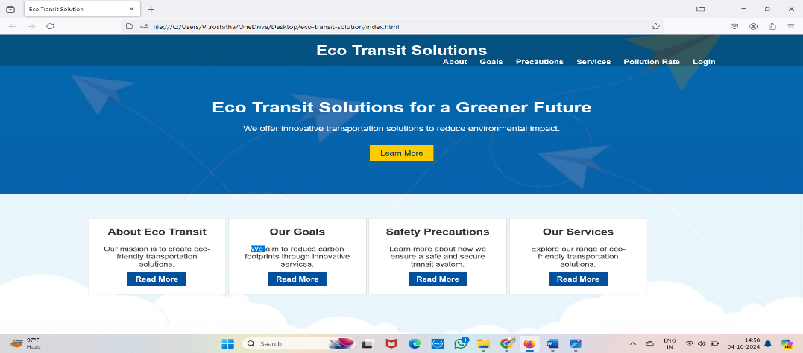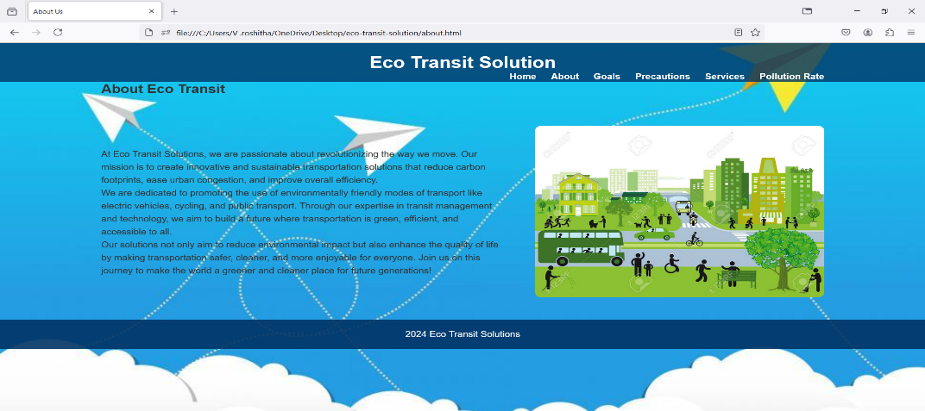

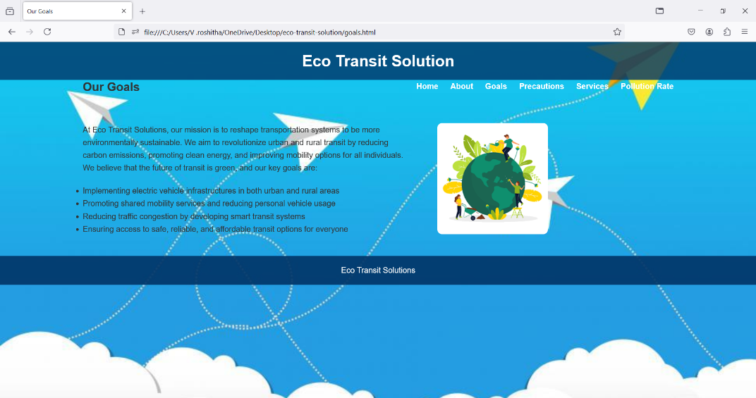

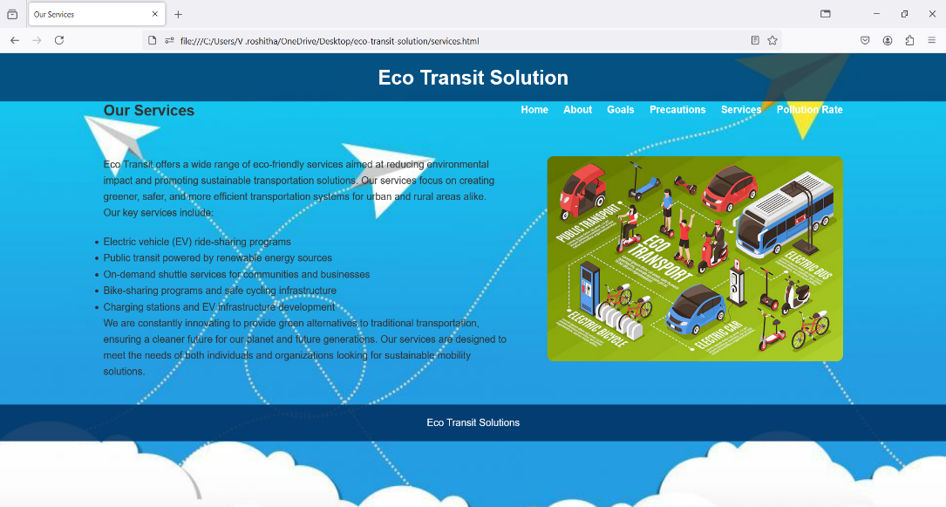

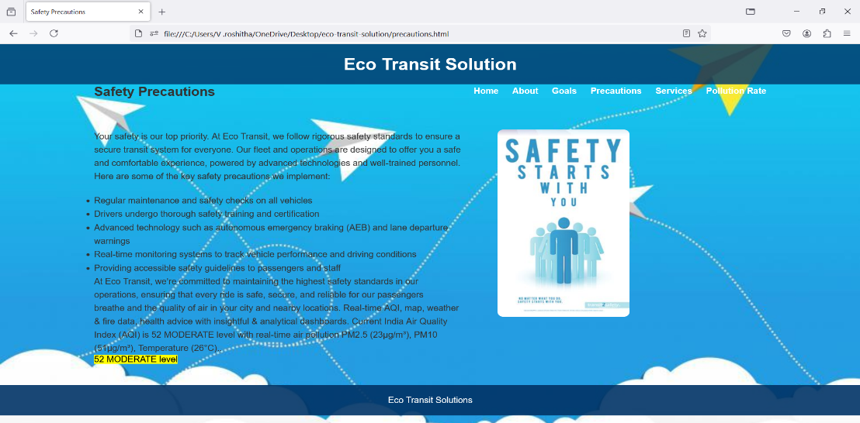

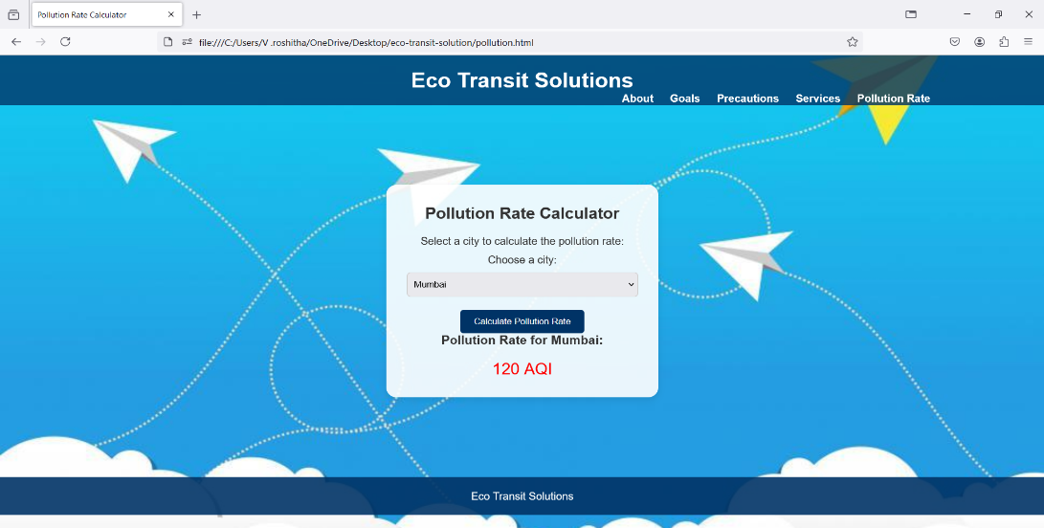

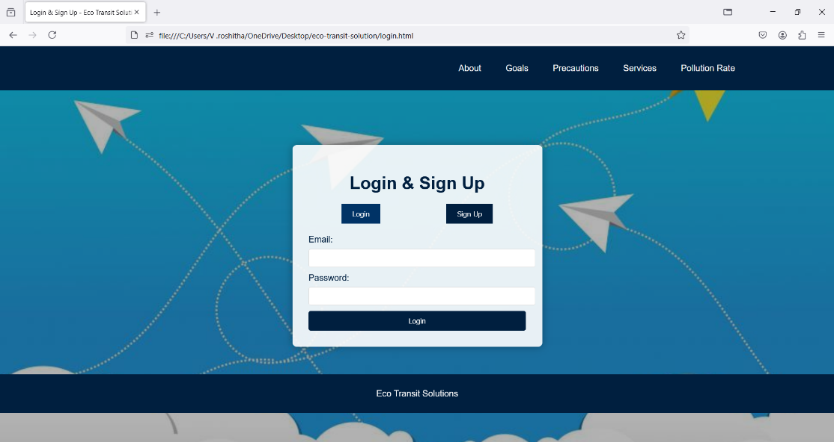

**Advantages:**

Environmentally Friendly: Encourages reduced carbon emissions and promotes sustainable transport methods.

Educational: Raises awareness about climate change, pollution, and how small changes in transit behavior can make a difference.

User-Friendly: The website design ensures ease of access to information, making it simple for users to understand and take action.

Community Impact: Encourages collective action towards a cleaner and healthier environment for future generations.

**Limitations:**

Dependence on User Participation: The platform’s success largely depends on users actively seeking out and adopting eco-friendly transit alternatives.

Limited Real-time Data: Although pollution statistics are available, real-time updates and GPS-enabled transport data might not be fully integrated.

Geographical Scope: The platform may focus on certain regions initially, limiting its global impact until further expansions.

**Conclusion:**

Eco Transit Solution is a valuable step toward creating a more sustainable future for urban transportation. By promoting the use of electric vehicles, cycling, public transport, and other eco-friendly modes of transport, the platform has the potential to significantly reduce carbon emissions and alleviate congestion in cities. While there are some limitations, the proposed solution offers substantial benefits and presents a vision of what the future of transportation could be—a cleaner, greener, and more efficient system for everyone.

**Future Scope:**

Integration with Real-time Data: Implement GPS and real-time tracking of public transport and pollution levels for better decision-making.

Mobile App Development: Build a mobile version of the platform to reach a wider audience.

Global Expansion: Extend the system’s reach to other regions and cities, incorporating their unique transit challenges and solutions.

Partnerships with Governments and NGOs: Collaborate with organizations to promote policies that incentivize eco-friendly transportation.

AI and Machine Learning: Use AI to predict traffic patterns and suggest the best eco-friendly routes for users based on real-time data.

**References**

Articles on Sustainable Transport and Pollution Control

Research papers on Electric Vehicles and their Impact on the Environment

Websites like:

* + [UN Environment Program](https://www.unep.org/)
  + [Greenpeace](https://www.greenpeace.org/)

Video editing and format conversion tools documentation (FFmpeg, HandBrake)

Web development tutorials and frameworks (Bootstrap, W3Schools)